Mobile Connect & Audio Enhancement
To use Mobile Connect as an audio enhancer you can either use your own device, or borrow one from us.

To use your own device:
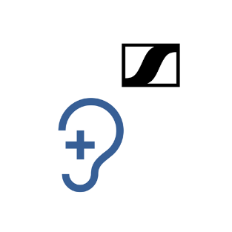
- Download the Sennheiser Mobile Connect app from the Apple app store or Google Play
- Connect to the ‘Mobile Connect’ Wi-Fi network (password: m0bileConn3ct)
You can only do this when you are in the venue.
- If you would like to connect to your hearing aids, you can do so through your hearing aid support app. Alternatively, you can use headphones.
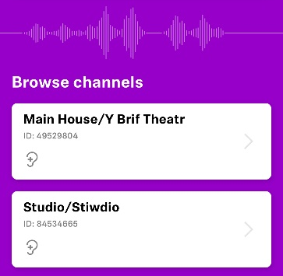
- Once you are connected. Open the app and select the channel pertaining to the auditorium you are in (Main House or Studio).

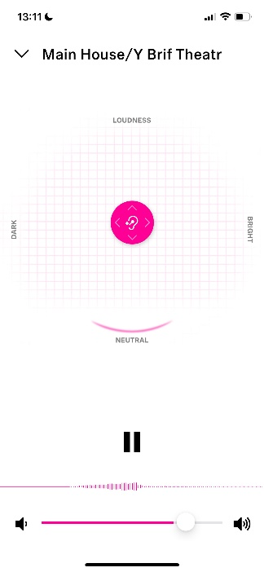
- Then select ‘Listen’

- From here, you will be able to hear the action on stage through the device and can adjust the audio to your preferences using the pink circle.

If you would like to borrow a device from us:
- Head to Box Office and ask to borrow a device for Mobile Connect
- The staff at Box Office will ask you for your name and seat number, so we can record the lend and retrieve the device(s) from you at the end of the performance. They will ask you which devices you would like to borrow. We can provide:
- A smartphone
- A pair of headphones (and aux. cable)
- A charging bank (and USBC charger)

- If you are borrowing a phone, it will already be fully charged and connected to the correct network. All you will need to do is pair your hearing aid to the device using you hearing aid support app. If you would prefer to use headphones, you can connect these now.
- Once you are connected, open the app and select the channel pertaining to the auditorium you are in (Main House or Studio).
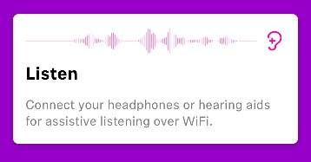
- Then select ‘Listen’

- From here, you will be able to hear the action on stage through the device and can adjust the audio to your preferences using the pink slider.

Troubleshooting:
- Mobile Connect is not the same as a hearing loop
- Not all hearing aid brands will be able to pair directly with Mobile Connect network. If you can’t connect directly, you can collect a neck loop from Box Office that will allow you to connect.
- The audio feedback will continue to run in the background of your device even if you lock it or move into other apps
- Connecting via Bluetooth headphones can cause a delay in audio feedback, so make sure to use wired headphones where possible. We can lend these out if necessary. We also have power banks and charging wires that we can provide if you would like to preserve your phone battery. These can all be collected from Box Office
- All borrow equipment must be handed in to an usher or returned to Box Office at the end of the performance.

